


Etek
Microelectronics

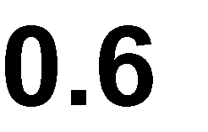
Ω

The ET5228H is an advanced CMOS analog switch fabricated in Sub−micron silicon gate CMOS technology. The part also features guaranteed Break Before Make (BBM) switching, assuring the switches never short the driver. The switches can handle negative signal down to -2.5V.
ET5228H is offered in a small QFN10L package, which is ideal for small form factor portable equipment.

- Low RON is typical 0.6Ω @ VCC =3.3V
- Single supply operation from 1.65V to 5.5V
- Full -2.5V to VCC signal handling capability
- High off-channel isolation
- Very low standby current
- Very low distortion
- Break-Before-Make(BBM) switching
- High continuous current capability is ±300mA through each switch
- Package information:

 |  | 
ET5228H | QFN10L (1.8mm×1.4mm) | Level 1

- Smart Phones and Cellular Phones
- Cell Phone Audio Block/ Speaker
- Earphone Switching Ring-Tone Chip
- Amplifier Switching/Modems

10 |  |  | 9 |  | 8
1 7
2 | 6
 | 3 | 4 5



NO2 COM2 IN2

VCC NC2

NO1 GND

COM1 IN1 NC1
Top View


 |  | 
1 | VCC | Power supply
2 | NO1 | Independent Channels
3 | COM1 | Common Channels
4 | IN1 | Controls
5 | NC1 | Independent Channels
6 | GND | Ground (V)
7 | NC2 | Independent Channels
8 | IN2 | Controls
9 | COM2 | Common Channels
10 | NO2 | Independent Channels



 | 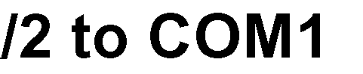 | 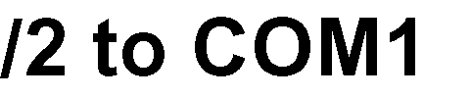
0 | OFF | ON
1 | ON | OFF


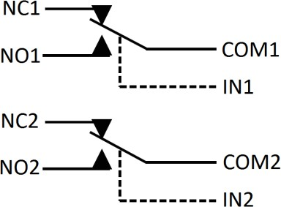

Analog Symbol

 |  |  |  | 
Supply Voltage |  | VCC | -0.5～+6.5 | V
Analog Input Voltage |  | VIS | -3～VCC+0.3  |VCC -VIS | <6.5V | V
Digital Select Input Voltage |  | VIN | -0.5～+6.5 | V
Output Voltage |  | VO | -3～VCC+0.3  |VCC -VO | <6.5V | V
Continuous DC Current from COM to NC/NO |  | IAN1 | ±300 | mA
Peak Current from COM to NC/NO, 10 Duty Cycle ⁽¹⁾ |  | IAN-PK1 | ±500 | mA
Continuous DC Current into  COM/NO/NC with Respect to VCC |  | ICLMP | ±100 | mA
Storage Temperature |  | TS | -55 to 150 | °C
ESD | Human Body Model ⁽²⁾ | HBM | ±6000 | V
ESD | Charge-Device Mode ⁽²⁾ | CDM | ±1500 | V
Latch Up (Current Maximum Rating) ⁽²⁾ |  | ILU | 200 | mA
Maximum ratings are those values beyond which device damage can occur. Maximum ratings applied to the device are individual stress limit values (not normal operating conditions) and are not valid simultaneously. If these limits are exceeded, device functional operation is not implied, damage may occur and reliability may be affected.
Note1.Defined as 10% ON, 90% off duty cycle.
Note2.This device series incorporates ESD protection and is tested by the following methods: ESD Human Body Model tested per ESDA/JEDEC JS-001-2017
CDM tested per ESDA/JEDEC JS-002-2018
Latch up Current Maximum Rating tested per JEDEC78

 |  |  | 
DC Supply Voltage | VCC | 1.65 | 5.5 | V
Digital Select Input Voltage | VIN | GND | 5.5 | V
Analog Input Voltage ⁽³⁾ | VIS | -2.5 | VCC | V
Operating Temperature Range | TA | -40 | +85 | °C
Input Rise or Fall Time, SELECT | tr , tf | 0 | 20 | ns/V
Note3. To ensure normal transmission of VIS, please follow |VCC -VIS | <5.5V.

 |  |  |  |     ℃ |  |  |     ℃
 |  |  |  |  | 
VIH | High-Level Input Voltage, Select Inputs | VCC = 1.65~5.5 | 1.65 | 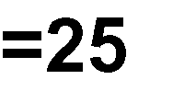  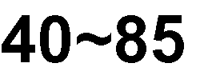  0.9 |  |  | 1.0 |  | V
VIH | High-Level Input Voltage, Select Inputs | VCC = 1.65~5.5 | 3.3 | 1.6 |  |  | 1.7 |  | V
VIH | High-Level Input Voltage, Select Inputs | VCC = 1.65~5.5 | 5.5 | 2.2 |  |  | 2.3 |  | V
VIL | Low-Level Input Voltage, Select Inputs | VCC= 1.65~5.5 | 1.65 |  |  | 0.4 |  | 0.35 | V
VIL | Low-Level Input Voltage, Select Inputs | VCC= 1.65~5.5 | 3.3 |  |  | 0.5 |  | 0.45 | V
VIL | Low-Level Input Voltage, Select Inputs | VCC= 1.65~5.5 | 5.5 |  |  | 0.6 |  | 0.55 | V
IIN | Maximum Input Leakage  Current, Select Inputs | VIN =VCC or GND  VCC =5.5V |  |  |  | ±0.3 |  | ±1.0 | uA
IOFF | Power Off  Leakage Current | VIN =5.5V  VCC =0V |  |  |  | ±0.5 |  | ±1.0 | uA
ICC | Maximum Quiescent  Supply Current ⁽⁴⁾ | VCC =5.5V, IOUT =0  VIN = VCC or GND |  |  |  | ±0.5 |  | ±1.0 | uA
ICCT | Increase in ICC per Input | IN1=2.6V, IN2=0V, or IN2=2.6V, IN1=0V,  VCC =4.3V |  |  | 1.5 | 3.0 |  | 10 | uA
ICCT | Increase in ICC per Input | IN1=1.8V, IN2=0V, or IN2=1.8V, IN1=0V,  VCC =4.3V |  |  | 4.5 | 7.0 |  | 20 | uA
ICOM(ON) | COM ON leakage Current ⁽⁵⁾ | VIN = VIL or VIH., VNO=0.3V or 4.7V  VNC floating VNC=0.3V or 4.7V  VNO floating VCOM=0.3Vor 4.7V  VCC =5.5V |  | -20 |  | 20 | -100 | 100 | nA
RON | On−Resistance ⁽⁴⁾ ⁽⁵⁾ | ICOM = 20mA VIS=-0.5V~0.5V,  VCC =4.3V |  |  | 0.5 | 0.8 |  | 0.9 | Ω
RON | On−Resistance ⁽⁴⁾ ⁽⁵⁾ | ICOM = 20mA,  VIS=-0.5V~0.5V, VCC =3.3V |  |  | 0.6 | 0.9 |  | 1.0 | Ω
RFLAT | On−Resistance Flatness (4) (5) (7) | ICOM=20mA VIS=-0.5V~0.5V, VCC =4.3V |  |  |  | 0.2 |  | 0.3 | Ω
∆RON | On−Resistance Match Between Channels ⁽⁴⁾ ⁽⁵⁾ ⁽⁶⁾ | ICOM=20mA VIS=0.5V  VCC =4.3V |  |  | 0.1 | 0.2 |  | 0.3 | Ω

 |  |  | ℃ |  |  | ℃
tON | Turn−On Time ⁽⁴⁾  (Figure 1) | VIS=0.5V,  VCC =2.5~3.3V |  | 35 | 55 |  |  | ns
tON | Turn−On Time ⁽⁴⁾  (Figure 1) | VIS=0.5V,  VCC =3.3~5.5V |  | 25 | 45 |  |  | ns
tOFF | Turn−Off Time ⁽⁴⁾  (Figure 1) | VIS=0.5V,  VCC =2.5~3.3V |  | 26 | 50 |  |  | ns
tOFF | Turn−Off Time ⁽⁴⁾  (Figure 1) | VIS=0.5V,  VCC =3.3~5.5V |  | 20 | 40 |  |  | ns
tBBM | Break-Before-Make Time ⁽⁴⁾ (Figure 2) | CL=35pF, RL=50Ω VIS=0.5V,  VCC =2.5~3.3V |  | 15 |  | 7 |  | ns
tBBM | Break-Before-Make Time ⁽⁴⁾ (Figure 2) | CL=35pF, RL=50Ω VIS=0.5V,  VCC =3.3~5.5V |  | 7 |  | 3 |  | ns
BW | On-Channel -3dB Bandwidth or Frequency  Response ⁽⁴⁾ (Figure 4) | RIS=50Ω |  | 65 |  |  |  | MHz
VISO | Off−Channel Isolation ⁽⁴⁾  (Figure 5) | FIS = 100kHz, VIN =GND to VCC CL=5pF，RL= 50Ω  VIS=1V VPP |  | -65 |  |  |  | dB
Q | Charge Injection Select Input to Common I/O ⁽⁴⁾ (Figure 3) | VIN = 0 or VCC RIS=0Ω,CL=100pF RL=1MΩ Q=CL×∆VOUT |  | 25 |  |  |  | pC
THD | Total Harmonic Distortion THD +Noise ⁽⁴⁾ | FIS=20Hz to 20KHz RL=50Ω,CL=5pF VIS=2V RMS  VCC =3.6V |  | 0.06 |  |  |  | %
THD | Total Harmonic Distortion THD +Noise ⁽⁴⁾ | FIS=20Hz to 20KHz RL=50Ω,CL=5pF VIS=2V RMS  VCC =5V |  | 0.03 |  |  |  | %
VCT | Channel−to−Channel Crosstalk ⁽⁴⁾  (Figure 6) | FIS= 100KHz, VIN =GND to VCC RL= 50Ω,CL=5pF  VIS=1V VPP |  | -90 |  |  |  | dB

 |  |    | ℃ |  |  | ℃
CIN | Control Pin Input Capacitance ⁽⁴⁾ | VCC =3.6V |  | 4.5 |  |  |  | pF
CNC/CNO | NC/NO Port Capacitance ⁽⁴⁾ | VCC =3.6V |  | 20.0 |  |  |  | pF
CCOM | COM Port Capacitance  When Switch is Enabled ⁽⁴⁾ | VCC =3.6V |  | 80.0 |  |  |  | pF
Note4. Guaranteed by design
Note5. Guaranteed by design. Resistance measurements do not include test circuit or package resistance
Note6. ∆RON = RON(NC1) - RON(NC2) or RON(No1) -RON(No2) when VIS is same.
Note7. Flatness is defined as the difference between the maximum and minimum value of on−resistance as measured over the specified analog signal ranges.


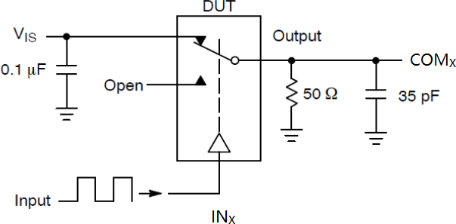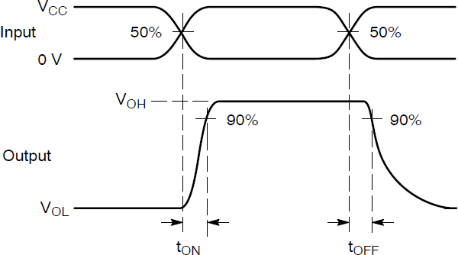

Figure1. tON /tOFF
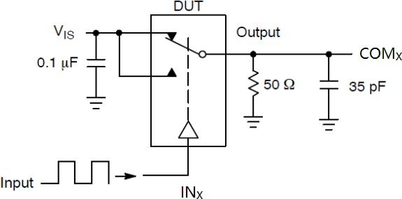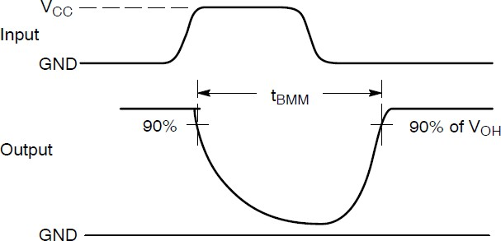

Figure2. tBBM
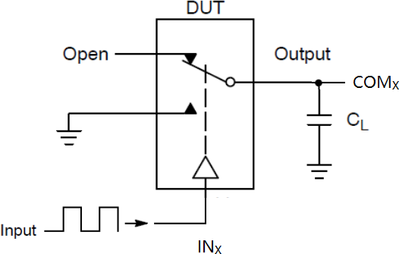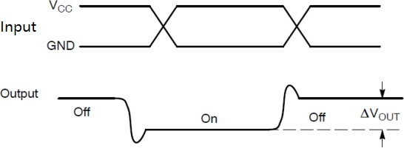
Figure3. Charge Injection



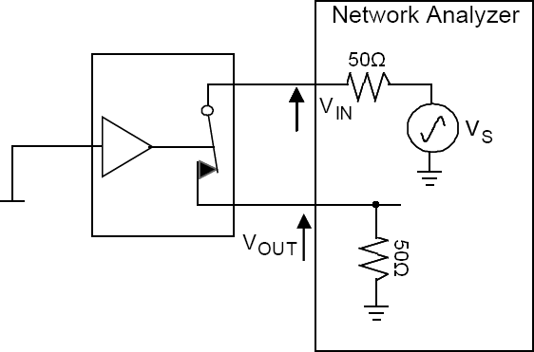
Figure4. Bandwidth
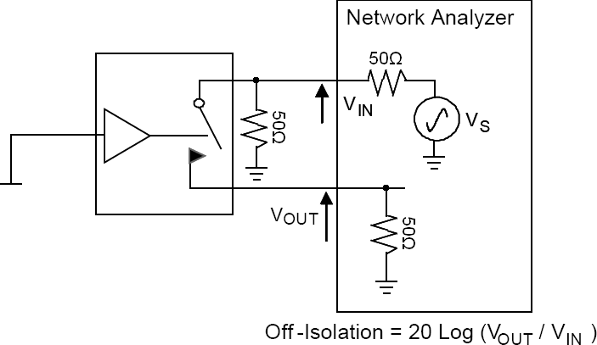
Figure5. Channel Off Isolation
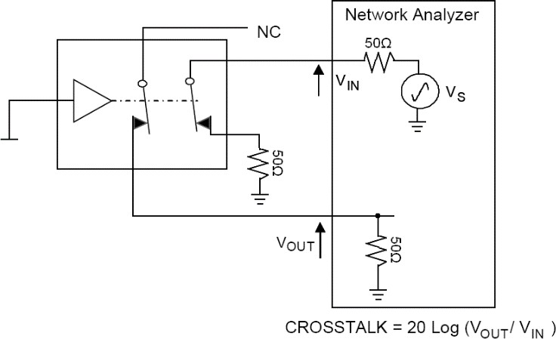
Figure6. Non-Adjacent Channel-to-Channel Crosstalk

0.55±0.05
0.4±0.05




QFN10L(1)
1.4±0.05
0.2±0.05
PIN1 MARK
PIN1
1 0.M±5 A0R0.K5
TOP VIEW
0.4
BOTTOM VIEW
0~0.05
0.152REF
SIDE VIEW
1.8±0.05

0.55±0.05
0.4±0.1

QFN10L(2)
1.4±0.05
0.2±0.05
PIN1 MARK
PIN1 MARK
1 0.5±0.1
TOP VIEW
0.4
BOTTOM VIEW
0~0.05
0.15REF
SIDE VIEW
1.8±0.05







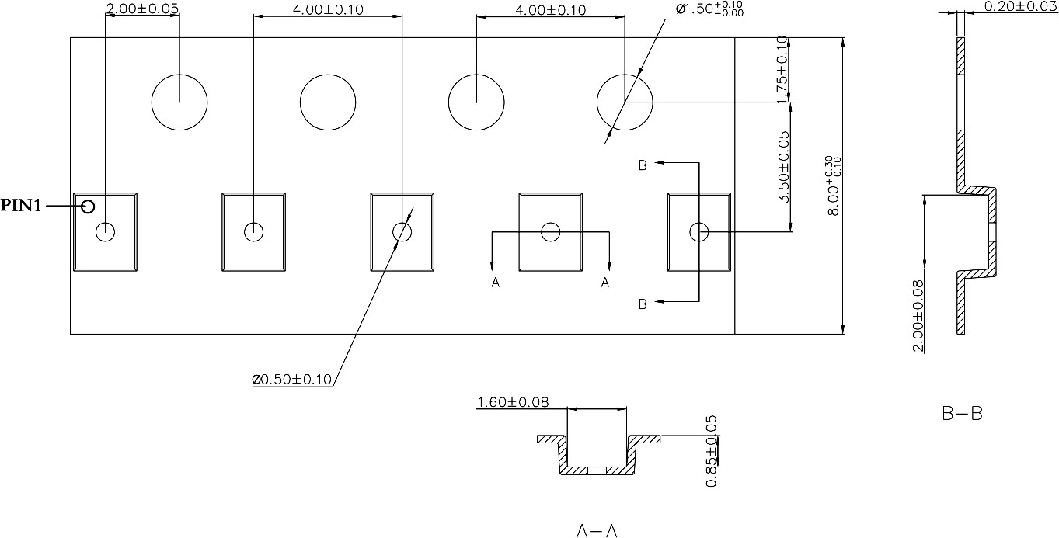


5228H - Part Number X - Tracking Number
Note：X (Tracking Number) is variable, according to the wafer lot number.

5228H X



Version | Date | Revision Item | Modifier | Function & Spec Checking | Package & Tape Checking
1.0 | 2019-10-17 | Original Version | liuxm | liujy | liujy
1.1 | 2020-01-02 | Add Tape Information | liuxm | Zhujl | Zhujl
1.2 | 2020-02-24 | documents check and  formalize | Shib | Liujy | Liujy
1.3 | 2020-02-28 | Add ESD value and update package  dimension picture | liuxm | liujy | liujy
1.4 | 2020-06-01 | Correct Typo | Wuxj | liujy | liujy
1.5 | 2020-07-22 | Update VIS and THD | Wuxj | liujy | liujy
1.6 | 2021-5-21 | Update package | Wuxj | liujy | liujy
1.7 | 2022-8-10 | Update Typeset | Wuxj | liujy | liujy

