
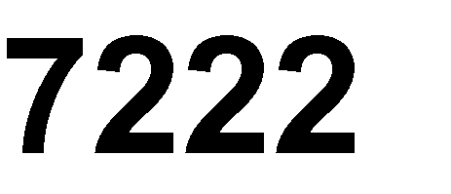

Etek Microelectronics



The ET7222 is a 2CH single-pole/double-throw (SPDT) switches. Their wide bandwidth and low bit-to-bit skew allow them to pass high-speed differential signals with good signal integrity.
Each switch is bidirectional and offers little or no attenuation of the high-speed signals at the outputs. Industry-leading advantages include a propagation delay of less than 250 ps, resulting from its low channel resistance and low I/O capacitance. Their high channel-to-channel crosstalk rejection results in minimal noise interference. Their bandwidth is wide enough to pass High-Speed USB 2.0 differential signals (480 Mb/s).
ET7222 is offered in a QFN10L and MSOP10 package.

- RON is typically 6.0 Ω @ VCC = 3.3 V
- Low Bit-to-Bit skew is typically 50 ps
- Low crosstalk is typical -37 dB @ 250 MHz
- Low current consumption is 1.0 µA typical
- Near-zero propagation delay is typical 250 ps
- Channel on-capacitance is 4.0 pF typical
- VCC Operating Range from 1.65 V to 4.5 V
- ≥ 750 MHz bandwidth (or data frequency)
- Part No. and package

 |  | 
ET7222 | QFN10L(1.8 mm×1.4 mm) | Level 1
ET7222U | MSOP10(4.9 mm×3.0 mm) | Level 1

- Differential Signal Data Routing
- USB 2.0 Signal Routing

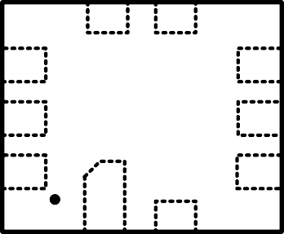


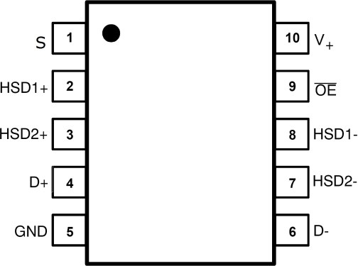


HSD1- HSD2-
7 6
OE 8
5 D-
VCC 9
4 GND
S
10
3 D+
1 2
HSD1+ HSD2+

QFN10L（ET7222）
MSOP10 (ET7222U)
Top View

 |  |  | 
 | 
1 | 2 | HSD1+ | Data Ports
2 | 3 | HSD2+ | Data Ports
3 | 4 | D+ | Data Ports
4 | 5 | GND | Ground
5 | 6 | D- | Data Ports
6 | 7 | HSD2- | Data Ports
7 | 8 | HSD1 | Data Ports
8 | 9 | OE | Output Enable
9 | 10 | VCC | Power supply
10 | 1 | S | Select Input



OE |  |  | 
1 | X | OFF | OFF
0 | 0 | ON | OFF
0 | 1 | OFF | ON










Analog Symbol

 |  |  |  | 
VCC | VCC | Positive DC Supply Voltage | -0.5 to +5.5 | V
VIS | HSD1+,HSD1-,HSD2+,HSD2- | Analog Signal Voltage | -0.5 to VCC +0.3 | V
VIS | D+,D- | Analog Signal Voltage | -0.5 to +5.5 | V
VIN | OE | Control Input Voltage | -0.5 to +5.5 | V
ICC | VCC | Positive DC Supply Current | 50 | mA
TS |  | Storage Temperature | -65 to +150 | ℃
IIS_CON | HSD1+,HSD1-,HSD2+,HSD2-  D+,D- | Analog Signal Continuous  Current-Closed Switch | ±100 | mA
IIS_PK | HSD1+,HSD1-,HSD2+,HSD2-  D+,D- | Analog Signal Continuous  Current 10% Duty Cycle | ±150 | mA
IIN | OE | Control Input Current | ±20 | mA
Stresses exceeding Maximum Ratings may damage the device. Maximum Ratings are stress ratings only. Functional operation above the Recommended Operating Conditions is not implied. Extended exposure to stresses above the Recommended Operating Conditions may affect device reliability.

 |  |  |  |  | 
VCC |  | Positive DC Supply Voltage | 1.65 | 4.5 | V
VIS | HSD1+,HSD1-,HSD2+,HSD2- | Analog Signal Voltage | GND | VCC | V
VIS | D+,D- | Analog Signal Voltage | GND | 4.5 | V
VIN | OE | Digital Select Input Voltage | GND | VCC | V
TA |  | Operating Temperature Range | -40 | +85 | ℃
Minimum and maximum values are guaranteed through test or design across the Recommended Operating Conditions, where applicable. Typical values are listed for guidance only and are based on the particular conditions listed for section, where applicable. These conditions are valid for all values found in the characteristics tables unless otherwise specified in the test conditions.


(Typical: TA = 25 °C, VCC = 3.3 V)

 |  |  |  |  | 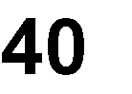 |  |  | 
 |  |  |  |  |  |  | 
VIH | OE | Control Input High Voltage⁽¹⁾ |  | 2.7  3.3  4.2 | 1.3  1.4  1.6 | - | - | V
VIL | OE | Control Input Low Voltage⁽¹⁾ |  | 2.7  3.3  4.2 | - | - | 0.4  0.4  0.5 | V
IIN | OE | Control Input  Leakage Current | 0 ≤ VIS ≤ VCC | 1.65 ~ 4.5 | - | - | ±1.0 | µA
Note1: VIH level is recommended to be consistent with VCC and VIL level is GND to reduce ICC current.
(Typical: TA = 25 °C, VCC = 3.3 V， OE = VCC or GND, S = VCC or GND)

ICC | VCC | Quiescent Supply  Current | VIS = VCC or GND;  IOUT = 0 A | 1.65 ~ 4.5 |  | 1.0 | µA
ICCT | VCC | Increase in ICC per  Control Voltage | VIN = 2.6 V | 3.6 |  | 10 | µA
IOZ | HSD1+ HSD1- HSD2+ HSD2- | OFF Stage Leakage Current | 0 ≤ VIS ≤ VCC | 1.65 ~ 4.5 |  | ±1.0 | µA
IOFF | D+, D- | Power OFF  Leakage Current | 0 ≤ VIS ≤ 4.5 V | 0 |  | ±1.0 | µA







(Typical: TA = 25 °C, VCC = 3.3 V)

 |  |  |  | 2.7 |  | 6.5 | 12
RON |  | On-Resistance |  | 3.3 | - | 6.0 | 10 | Ω
 |  |  |  | 4.2 |  | 5.5 | 8
 |  |  | VIS = 0.2 V, | 2.7 |  | 0.3 | 1.5
RFLAT |  | On-Resistance Flatness | 0.4 V | 3.3 | - | 0.2 | 1 | Ω
 |  |  | ION = 8 mA | 4.2 |  | 0.1 | 0.5
 |  |  |  | 2.7 |  | 0.25 | 0.5
△RON |  | On-Resistance Matching |  | 3.3 | - | 0.2 | 0.45 | Ω
 |  |  |  | 4.2 |  | 0.15 | 0.4



(Typical: TA = 25 °C, VCC = 3.3 V)

RON |  | On-Resistance | VIS=0.2VCC, 0.5VCC,  0.8VCC, VCC ION = 8 mA | 2.7  3.3  4.2 | - | 9.0  7.5  6.0 | 12.5  10.5  8.5 | Ω
△RON |  | On-Resistance Matching | VIS=0.2VCC, 0.5VCC,  0.8VCC, VCC ION = 8 mA | 2.7  3.3  4.2 | - | 0.5  0.4  0.3 | 0.8  0.7  0.6 | Ω
RFLAT |  | On-Resistance Flatness | VIS=0.2V, 0.4V,  0.7V,1.0V  ION = 8 mA | 2.7  3.3  4.2 | - | 1.0  0.5  0.4 | 3  1.5  1.2 | Ω
(Typical: TA = 25 °C, VCC = 3.3 V, RL = 50 Ω, CL = 5 pF, f = 1 MHz)

tON | Closed to Open | Turn-ON Time |  | 2.7 ~ 4.5 | - | 14 | 30 | ns
tOFF | Open to Closed | Turn-OFF Time |  | 2.7 ~ 4.5 | - | 22 | 30 | ns
tBBM |  | Break-Before-  Make Delay | VIS = 0 V  to VCC | 2.7 ~ 4.5 | 2 | 8 | - | ns
BW |  | -3 dB  Bandwidth | CL= 5 pF | 2.7 ~ 4.5 | - | 550 | - | MHz
BW |  | -3 dB  Bandwidth | CL= 0 pF | 2.7 ~ 4.5 | - | 750 | - | MHz

 (Typical: TA = 25 °C, VCC = 3.3 V, RL = 50 Ω, CL = 5 pF, f = 1 MHz)

 |  |  |  |  | 
OIRR | Open | OFF-Isolation | f= 250 MHz | 1.65 ~ 4.5 | - | -25 | - | dB
XTALK | HSD1+ to  HSD1- | Non-Adjacent  Channel Crosstalk | f= 250 MHz | 1.65 ~ 4.5 | - | -37 | - | dB

(Typical: TA = 25 °C, VCC = 3.3 V, RL = 50 Ω, CL = 5 pF, f = 1 MHz)

CIN | OE | Control Pin Input  Capacitance |  | 0 |  | 1.8 |  | pF
CON | D+ to  HSD1/2+ | ON Capacitance | VOE= 0 V | 3.3 |  | 4.0 |  | pF
COFF | HSD2+,  HSD2- | OFF Capacitance | VIS = 3.3 V  VOE= 3.3 V | 3.3 |  | 2.2 |  | pF

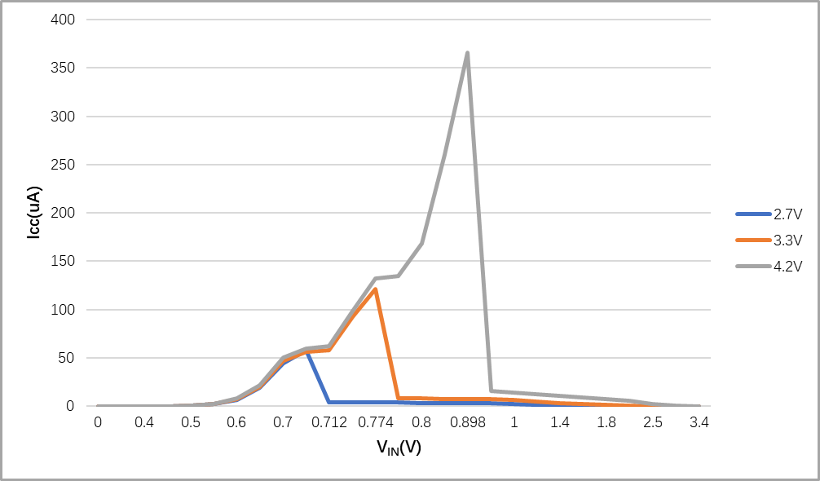
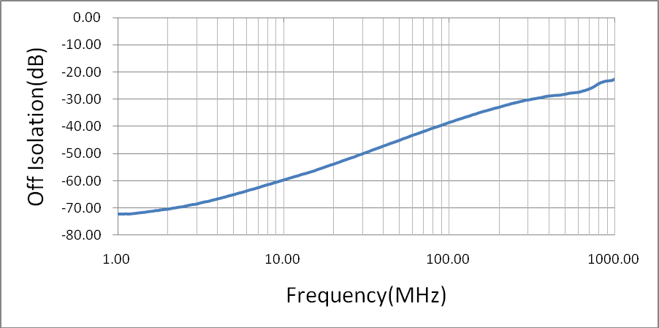
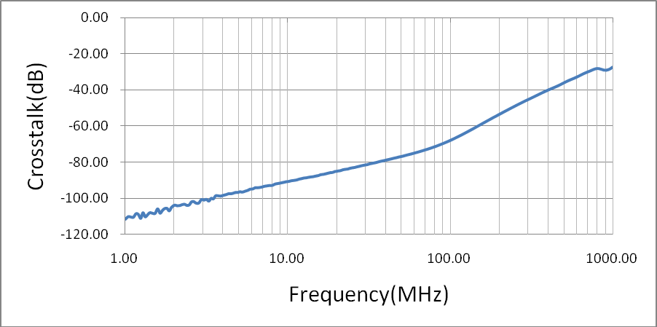


Figure1-a. ICC vs. VIN

OFF-ISOLATION
Figure1-b. Response vs. Frequency

CROSSTALK
Figure1-c. Response vs. Frequency


0.1uF
Switch Select Pin
tBBM
50% OF VOLTAGE
Output DROOP DROOP
35pF
50Ω
Vout
DUT
Figure2. tBBM (Time Break-Before-Make)
Vcc
VCC Input
Output
GND
tON
Input
Figure3. tON / tOFF
tOFF
Vcc
DUT
Output

VOL
90%
90%
35pF
50Ω
VOH
Open
0.1uF
Vout
Output
50%
50%
Vcc
tON
tOFF
Figure4. tON / tOFF
DUT
Vcc
Input
10%
10%
Output

VOL
35pF
VOH
Open
Vout
Output
50%
50%
Vcc Input
0V
50Ω

Figure5. Off Channel Isolation/On Channel Loss(BW)/Crosstalk

(On Channel to Off Channel)/VONL
50Ω
DUT
Reference

Input
Transmitted
50 Ω Generator
Output
50Ω
Channel switch control/s test socket is normalized. Off isolation is measured across an off channel. On loss is the bandwidth of an On switch. VISO, Bandwidth and VONL are independent of the input signal direction.

VISO = Off Channel Isolation = 20 Log ⎛ VOUT ⎞

for VIN at 100 kHz.

⎜ ⎟
⎝ Vin ⎠

VONL = On Channel Loss = 20 Log ⎛ VOUT ⎞
for VIN at 100 kHz to 50 MHz.

⎜ ⎟
⎝ Vin ⎠

Bandwidth (BW) = the frequency 3 dB below VONL.

VCT = Use VISO setup and test to all other switch analog input/outputs terminated with 50 Ω.

TA = +25 °C, Unless Otherwise Specified
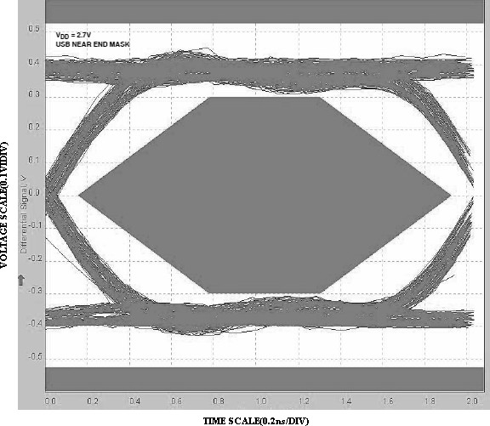
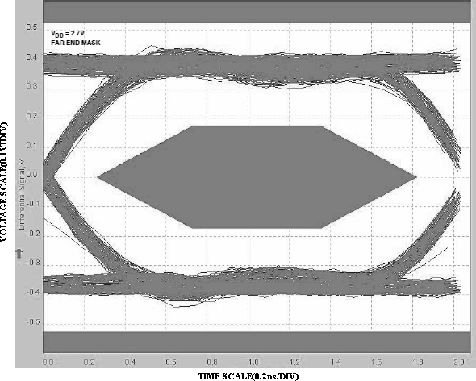

Figure6. Eye Pattern : 480 Mbps with USB Switches the Signal Path

Figure7. Eye Pattern : 480 Mbps with USB Switches in the Signal Path

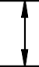



QFN10L

b L1
L

A2
e
E

D

A1
A

COMMON DIMENSIONS (UNITS OF MEASURE=MILLIMETER)
 |  |  | 
A | 0.500 |  | 0.600
A1 | 0.000 |  | 0.050
A2 | 0.152 TYP
b | 0.150 | 0.200 | 0.250
D | 1.350 | 1.400 | 1.450
E | 1.750 | 1.800 | 1.850
e | 0.400 TYP
L | 0.350 | 0.400 | 0.450
L1 | 0.450 | 0.500 | 0.550




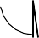
MSOP10

D c

L
E
E1

θ
b e

A1
A2
A

COMMON DIMENSIONS (UNITS OF MEASURE=MILLIMETER)

A | 0.82 | 0.95 | 1.10
A1 | 0.02 | 0.07 | 0.15
A2 | 0.75 | 0.85 | 0.95
b | 0.18 | 0.23 | 0.28
c | 0.09 | 0.16 | 0.23
D | 2.90 | 3.00 | 3.10
E | 4.75 | 4.90 | 5.05
E1 | 2.90 | 3.00 | 3.10
e | 0.50 TYP
L | 0.40 |  | 0.80
θ | 0° |  | 6°

.

 |  |  |  |    |   
1.0 | 2012-08-07 | Preliminary Version | Liuxm | Liuxm | Zhujl
1.1 | 2016-02-01 | Add some parameters | Liuxm | Liuxm | Zhujl
1.2 | 2017-03-10 | Updated typo | Wuxj | Wuxj | Zhujl
1.3 | 2019-02-01 | Update format | Liuxm | Liuxm | Liujy
1.4 | 2019-04-12 | According to the test results Update Typical Value of On-Resistance Flatness, On-Resistance Matching , Turn-OFF Time, OFF-Isolation,  Non-Adjacent Channel Crosstalk | Liuxm | Liuxm | Liujy
1.5 | 2019-06-25 | Updated:  1.VIH,VIL Test Spec 2.RON,RFLAT,∆RON Test Conditions  - RFLAT Test Spec  - Add max RON, RFLAT, ∆RON value  - Add Min tBBM value  - ICC vs. VIN,  OFF-ISOLATION,CROSSTALK graph | Liuxm | Liuxm | Zhujl
1.6 | 2019-09-29 | Updated OFF-ISOLATION and  CROSSTALK | Liuxm | Liuxm | Zhujl
1.7 | 2020-03-06 | Documents check and formalize | Shib | Shib | Liujy
1.8 | 2022-08-31 | Update Typeset | Qinpl | Qinpl | Liujy

